**MINI PROJECT REPORT**

*On*

**Floyd’s tortoise and hare algorithm to find the cycle**

**K. K. WAGH INSTITUTE OF ENGINEERING EDUCATION AND RESEARCH, NASHIK**

**DEPARTMENT OF COMPUTER ENGINEERING**

*A report submitted in partial fulfillment of the requirements for the Award of Degree of*

BACHELOR OF ENGINEERING

*In*

COMPUTER ENGINEERING

*By*

DEVENDRA SOLUNKE(BE A37 , COMPUTER 2022-23)

GAYATRI DESHMUKH(BE A 38, COMPUTER 2022-23)

SARTHAK WAGH (BE A 39, COMPUTER 2022-23)

ADITYA AGRAWAL(BE A 40, COMPUTER 2022-23)

**Problem Statement:**

# Floyd’s tortoise and hare algorithm to finding the cycle .

# Description:

The algorithm is to start two pointers, slow and fast from head of linked list. We move slow one node at a time and fast two nodes at a time. If there is a loop, then they will definitely meet. This approach works because of the following facts. 1) When slow pointer enters the loop, the fast pointer must be inside the loop.

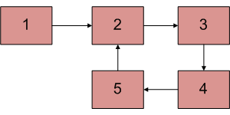

Let fast pointer be distance k from slow. 2) Now if consider movements of slow and fast pointers, we can notice that distance between them (from slow to fast) increase by one after every iteration. After one iteration (of slow = next of slow and fast = next of next of fast), distance between slow and fast becomes k+1, after two iterations, k+2, and so on. When distance becomes n, they meet because they are moving in a cycle of length n. For example, we can see in below diagram, initial distance is 2. After one iteration, distance becomes 3, after 2 iterations, it becomes 4. After 3 iterations, it becomes 5 which is distance 0. And they meet.

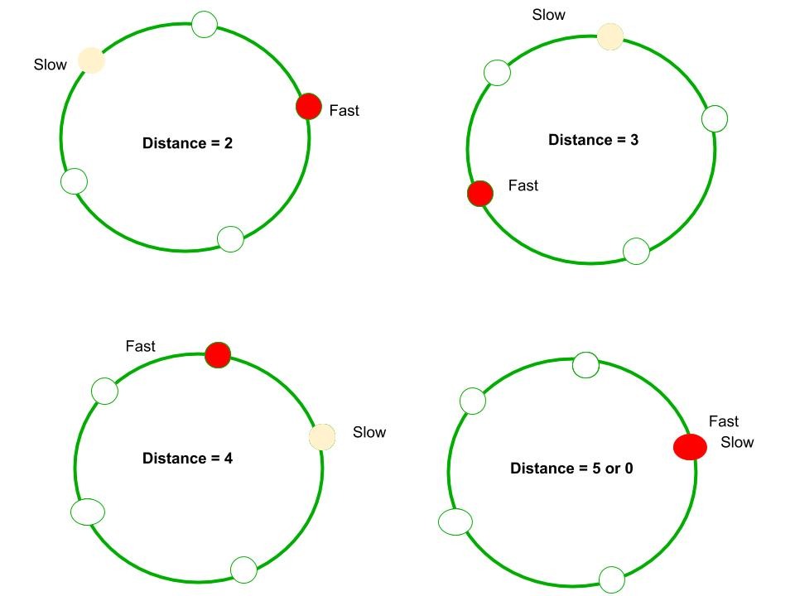

According to above figure at the 4th circle fast and slow pointer are meeting each other

Hence proved

**Application problem :**

Write an algorithm to determine if a number n is happy.

A **happy number** is a number defined by the following process:

* Starting with any positive integer, replace the number by the sum of the squares of its digits.
* Repeat the process until the number equals 1 (where it will stay), or it **loops endlessly in a cycle** which does not include 1.
* Those numbers for which this process **ends in 1** are happy.

Return true *if* n *is a happy numb* **Example 1:**

**Input:** n = 19

**Output:** true

**Explanation:**

12 + 92 = 82

82 + 22 = 68

62 + 82 = 100

12 + 02 + 02 = 1

*er, and* false *if not*.

package com.example.devendra.linkedlist;  
// https://practice.geeksforgeeks.org/problems/next-happy-number4538/1  
public class HappyNumber {  
 public static void main(String[] args) {  
 int n = 13;  
 boolean ans = *find*(n);  
 System.*out*.println(ans);  
 }  
 static boolean find(int n){  
 int slow = n;  
 int fast = n;  
 do {  
 slow = *findSquare*(slow);  
 fast = *findSquare*(*findSquare*(fast));  
 }while (fast != slow);  
 if(slow == 1){  
 return true;  
 }else {  
 return false;  
 }  
 }  
  
 private static int findSquare(int n) {  
 int ans = 0;  
 while (n > 0){  
 int rem = n % 10;  
 ans = ans + rem * rem;  
 n /= 10;  
 }  
 return ans;  
 }  
}

Output :

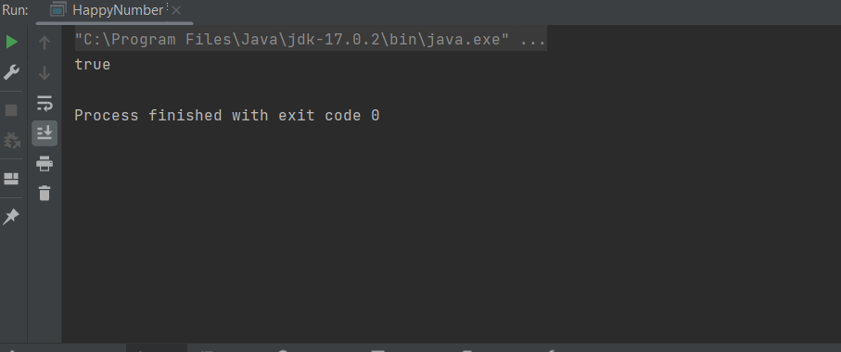

# Time Complexity:

* The time complexity for obtaining MST from the given graph is O(V^2) where V is the number of nodes.
* The time complexity for obtaining the DFS of the given graph is O(V+E) where V is the number of nodes and E is the number of edges.
* Hence the overall time complexity is O(V^2).

# Space Complexity:

* The worst case space complexity for the same is O(V^2), as we are constructing a vector<vector<int>> data structure to store the final MST.
* The space complexity for the DFS is O(V).
* Hence space complexity of this algorithm is O(V^2).

diagnostics in time. The model can also serve the purpose of training tool for medical students

and will be a soft diagnostic tool available for physician and cardiologist. General physicians can

utilize this tool for initial diagnosis of cardio-patients. There are many possible improvements

that could be explored to improve the scalability and accuracy of this prediction system. As we

have developed a generalized system, in future we can use this system for the analysis of

different data sets. The performance of the health’s diagnosis can be improved significantly by

handling numerous class labels in the prediction process, and it can be another positive direction

of research. In DM warehouse, generally, the dimensionality of the heart database is high, so

identification and selection of significant attributes for better diagnosis of heart disease are very

challenging tasks for future research.

The proposed working model can also help in reducing treatment costs by providing Initial

diagnostics in time. The model can also serve the purpose of training tool for medical students

and will be a soft diagnostic tool available for physician and cardiologist. General physicians can

utilize this tool for initial diagnosis of cardio-patients. There are many possible improvements

that could be explored to improve the scalability and accuracy of this prediction system. As we

have developed a generalized system, in future we can use this system for the analysis of

different data sets. The performance of the health’s diagnosis can be improved significantly by

handling numerous class labels in the prediction process, and it can be another positive direction

of research. In DM warehouse, generally, the dimensionality of the heart database is high, so

identification and selection of significant attributes for better diagnosis of heart disease are very

challenging tasks for future research.

The proposed working model can also help in reducing treatment costs by providing Initial

diagnostics in time. The model can also serve the purpose of training tool for medical students

and will be a soft diagnostic tool available for physician and cardiologist.

The proposed working model can also help in reducing treatment costs by providing Initial

diagnostics in time. The model can also serve the purpose of training tool for medical students

and will be a soft diagnostic tool available for physician and cardiologist.

The proposed working model can also help in reducing treatment costs by providing Initial

diagnostics in time. The model can also serve the purpose of training tool for medical students

and will be a soft diagnostic tool available for physician and cardiologist.

The proposed working model can also help in reducing treatment costs by providing Initial

diagnostics in time. The model can also serve the purpose of training tool for medical students

and will be a soft diagnostic tool available for physician and cardiologist

The proposed working model can also help in reducing treatment costs by providing Initial

diagnostics in time. The model can also serve the purpose of training tool for medical students

and will be a soft diagnostic tool available for physician and card